
Windows XP Service Pack 2 Overview
White Paper
Published: February 2004
For the latest information, please see http://msdn.microsoft.com/security

Contents
Abstract 1
Introduction 2
New Security Challenges 2
A More Secure System 3
Easier Maintenance 4
Implications of the Improvements 5
Network protection 6
Windows Firewall 6
Remote Procedure Call (RPC) 8
Distributed Component Object Model (DCOM) 8
Alerter and Messenger services 9
Memory protection 10
Execution Protection (NX) 10
Sandboxing 10
Safer message handling 11
Attachment Execution Service (AES) 11
AES in Outlook Express and Windows Messenger 11
HTML content blocking in Outlook Express 12
More secure browsing 14
Improved computer maintenance 16
Windows Update 5 16
Windows Installer 3 16
Security Center 17
Summary 18
Glossary 19

Abstract
Windows XP Service Pack 2 addresses new challenges to the security of personal computers by making a number of basic improvements to the operating system. It reduces common attack vectors four ways: it enhances protection of the network, increases protection for memory, handles e-mail more safely, and browses the Internet more securely. Service Pack 2 also makes it easier to keep the system up-to-date; makes it easier for an administrator to control security throughout an enterprise; and makes it easier to use Bluetooth devices from Windows. Service Pack 2 also includes DirectX 9 and Windows Media Player 9, which contain security, performance, and functionality improvements.

Introduction
Historically, operating systems have had to find a balance between ease of use and security. Early versions of Windows were designed primarily for ease of use, which was appropriate for computers used by one person, without any connection to the outside world beyond an occasional shared floppy diskette. For an isolated, single-user system, even requiring a username and password seemed unnecessary.
Today's connected computing environment commonly exposes computers to a variety of security threats. The majority of computers connect to the Internet at least occasionally. Almost all computers are used for e-mail and/or Web browsing. Many computers connect to the Internet full-time over cable modem or DSL links, or through corporate networks. Most of these are also used to play music and view video content. Many users enjoy instant messaging and peer-to-peer collaboration programs, as well as interactive games. Each of these conveniences also exposes the computer to new threats.

New Security Challenges
Widespread connectivity has opened the door to fast-spreading computer viruses, worms and Trojan horse programs. Computer users have protected themselves from these threats by using firewalls and antivirus programs, and by applying system and application patches as they become available. Microsoft has responded to threats that take advantage of system flaws by developing, testing, and distributing system and application patches to fix those flaws. Antivirus vendors update their virus signature files as often as daily as new viruses are detected.
The cycle in which vendors constantly supply new virus signatures and new system patches in response to each outbreak of new viruses and worms is not really a cure for the problem. It is only a continual attempt to alleviate the problem, which can never quite anticipate the next threat. Essentially, in this scenario we can't drain the ocean that's threatening to flood our farmlands: we can only keep plugging the dikes. Defense by updates and patches not only requires constant work from vendors, it also requires users to be diligent about downloading and applying the updates and patches promptly, which can become a significant burden.
Users are not always diligent about applying patches. For example, the Blaster worm, which was discovered August 11, 2003, exploited a Remote Procedure Call (RPC) security vulnerability for which a patch had already been issued. A firewall could also easily stop Blaster by closing the port used by RPCs. While many users had already applied the patch and/or had a firewall in place, many had not: so many left themselves vulnerable that the worm spread rapidly throughout the world, seriously affecting Internet and corporate network bandwidth for several days.
Late in August and early in September, Blaster again became a problem, when students arrived at colleges and universities for the fall term with infected computers. In some cases, these naïve students compromised the college's entire network. Some colleges, ones that instituted isolation zones, mandatory system patching, and mandatory antivirus policies, had no network problems, although individual students were inconvenienced by having their campus network and Internet access delayed by the security measures until their computers were certified to be virus-free and in compliance with network policies. Other colleges and universities that started out with permissive policies were forced to shut down their networks completely for hours, and to distribute patches and antivirus software on CD, dorm to dorm.
Administrators have not been immune to such problems, either. The W32.Slammer worm aggressively compromised SQL Server installations worldwide in January, 2003, flooding many enterprise networks and major portions of the Internet, and denying service to many Web sites. However, W32.Slammer was discovered six months after a patch had been issued to fix the vulnerability exploited by the worm. In many cases, administrators had delayed applying the patch to public SQL Server instances because they wanted to avoid downtime on shared databases. The same attitude kept administrators from applying a subsequent service pack that included the patch. The result was, unfortunately, more downtime and much more disruption from the worm than would have resulted from the application of the original patch and/or the service pack.
Not even large organizations and branches of government are immune. In December, 2003, the US Treasury Department's Inspector General Report criticized the department's information security systems, including the Internal Revenue Service, for (among other issues) failing to apply vendor patches to systems, leaving them open to known vulnerabilities.
With Windows XP Service Pack 2, Microsoft has rolled up the patches to all known vulnerabilities to the Windows XP operating system and its utilities. In addition, it has attempted to increase the inherent security of the system in the face of future threats, whether or not the system is fully patched, while making the process of obtaining and applying the appropriate patches easier and less time-consuming. At the same time, Microsoft has attempted to maintain Windows XP's ease of use, with simple but flexible user interfaces to the new functionality.

A More Secure System
The major goal of Windows XP Service Pack 2 is to reduce common openings for attack of the Windows operating system. It reduces the most common attack vectors four ways: it better shields the network, enhances protection of memory, handles e-mail more safely, and browses the Internet more securely.
Network protection is the largest area of improvement in Windows XP Service Pack 2, and the one with the most implications for existing software. It starts with an improved Windows Firewall (previously known as Internet Connection Firewall, or ICF), which is enabled by default. The new firewall turns on very early in the system boot cycle, before the network stack is fully enabled, reducing the possibility of intrusions during the boot cycle. It also turns off very late in the shutdown cycle, after the network stack has been disabled, reducing the possibility of intrusions during system shutdown.
Windows Firewall is now enabled for all network interfaces by default, has a convenient control panel graphical user interface to enable exceptions by application, and can be placed under administrative control in a domain through new Group Policy settings. In addition, the netsh command-line tool, which was added to Windows XP in the Advanced Networking Pack to support IPv6, has been enhanced to support Windows Firewall configuration.
The Remote Procedure Call (RPC) service has been made less vulnerable to outside attack, and new permission levels have been added to allow administrators to control which RPC servers are blocked, which are exposed only to the local subnet, and which are exposed to the entire network. Windows Firewall has been enhanced to support these permissions, and to limit port openings from alleged RPC servers based on the security context in which they run.
The Distributed Component Object Model (DCOM) infrastructure has additional access control restrictions to reduce the risk of a successful network attack. By default, only authenticated administrators can remotely activate and launch COM components, and only authenticated users can remotely call COM components. Administrators can apply fine control to individual services to allow only appropriate users to use the services, or to restrict services to local use.
On CPUs that support execution protection (NX) technology, Windows XP Service Pack 2 marks data pages non-executable. This feature of the underlying hardware prevents execution of code from pages marked in this way. This prevents attackers from overrunning a marked data buffer with code and then executing the code; it would have stopped the Blaster worm dead in its tracks. The only processor families that currently support NX are the 64-bit AMD K8 and Intel Itanium; however, Microsoft expects future 32-bit and 64-bit processors to provide hardware based execution protection..
In addition to supporting NX, Service Pack 2 implements sandboxing. All binaries in the system have been recompiled with buffer security checks enabled to allow the runtime libraries to catch most stack buffer overruns, and "cookies" have been added to the heap to allow the runtime libraries to catch most heap buffer overruns.
In SP2, a new version of Outlook Express can block images and other external content in HTML email, warn about other applications trying to send mail, and control the saving and opening of attachments that could potentially be a virus. Outlook Express also coordinates with the new application execution service, to better protect the system from the execution of harmful attachments. Users also have the option to read or preview all messages in plain text mode, which can avoid potentially unsafe HTML. Windows Messenger and MSN Messenger share the improvements to attachment control made for Outlook Express.
Internet Explorer (IE) has been made much more secure in Service Pack 2. It now manages add-ons and detects crashes due to add-ons, controls whether or not binary behaviors are allowed to run, and applies the same safety restrictions to all URL objects that previously applied only to ActiveX controls. It has more control over the execution of all content. It dramatically restricts the capabilities of the Local Machine zone, to block attacks that attempt to use local content to run malicious HTML code. IE now requires that all file-type information provided by Web servers be consistent, and "sniffs" files for malicious code trying to masquerade as a benign file type.
IE now disallows access to cached scriptable objects: HTML pages can only script their own objects. This better blocks attacks on the IE cross-domain security model, disallowing scripts that listen to events or content in other frames, such as a script that might try to capture credit card information from a form. IE now has a built-in facility to block unwanted pop-up windows, and manage the viewing of desired pop-up windows. It can block all signed content from an untrusted publisher, will block signed code with invalid digital signatures by default, and will only display one prompt per control per page. Further, IE now keeps scripts from moving or resizing windows and status bars to hide them from view or obscure other windows.
DirectX 9 and Windows Media Player 9 both contain security, performance, and functionality improvements. For more information about improvements to DirectX, consult the DirectX home page at http://www.microsoft.com/windows/directx/. For more information about improvements to Windows Media Player, refer to the Windows Media Player home page at http://www.microsoft.com/windows/windowsmedia/.

Easier Maintenance
Windows XP Service Pack 2 features automatic updates, using Windows Update Version 5. An Express Install option makes it easy for users to quickly get just the critical and security updates they need, and an Automatic Updates control panel makes updating a set-and-forget task instead of a constant chore. In addition, Microsoft has endeavored to make most new patches smaller than they have been in the past, although Service Pack 2 is itself huge.
The new Security Center provides a central location for information about the security of your computer, with an easy-to-use graphical interface. Windows Installer 3.0 provides more security options for software installation, and provides patch management infrastructure that helps to keeps patches small through "delta compression" technology. Windows Installer 3.0 helps to avoid the downloading of unneeded, superseded or obsolete patches, and supports patch removal reliably.

Implications of the Improvements
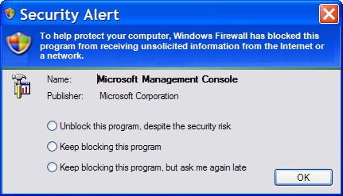
Overall, most of the improvements introduced with Windows XP Service Pack 2 serve to make the operating system more secure without materially affecting the user experience. However, there are a few areas where users, administrators, and developers will have to make adjustments to maintain functionality without compromising security.
For users, the most common adjustments have to do with allowing exceptions to the improved security. Users who never ran ICF before will see a new popup security alert dialog whenever they run a new application that wants to act as an Internet server. Users will need to think about whether they want to grant each application this privilege, but they only have to think about it once, and they can change their minds easily later. Most users will want to allow their preferred instant messaging application this privilege when they expect to receive a video. Most users will deny the privilege to an unfamiliar application, especially if the publisher is unknown, lest it turn out to be a virus, worm, or Trojan horse.
Users will also find that Security Center nags them a bit if they lack an antivirus program, if their antivirus signatures are out of date, if they ignore critical system updates, or if they turn off their firewall. Most users will find this extra vigilance by the operating system more of a comfort than an annoyance; knowledgeable users can turn off any incorrect warnings by telling Security Center about their third-party security applications.
Users who have regularly scheduled tasks on their system may have to revisit them, once, to enter passwords. Scheduled tasks created to use the default security context, rather than a specific user ID, no longer work in Windows XP Service Pack 2. This helps limit a potential avenue of attack for intruders.
Administrators will need to explicitly allow access to server applications on their networks. Since access can be limited to the local subnet or allowed from any source, administrators have more control than ever before. Administrators and other IT professionals should read about this in detail on the Windows XP SP2 Web site, paying specific attention to http://msdn.microsoft.com/library/default.asp?url=/library/en-us/dnwxp/html/securityinxpsp2.asp.
Windows and Web application developers will have to revisit distributed applications that use RPCs or DCOM. They may also have to apply patches to their development tools and allow their tools Windows Firewall privileges to allow remote debugging to work.
Web application developers may also have to reexamine their use of ActiveX controls and binary behaviors and make minor adjustments, as security has been tightened around these technologies. Web pages that need to run locally and have active content may need an additional "signature" line or a change of extension to allow them to run correctly.

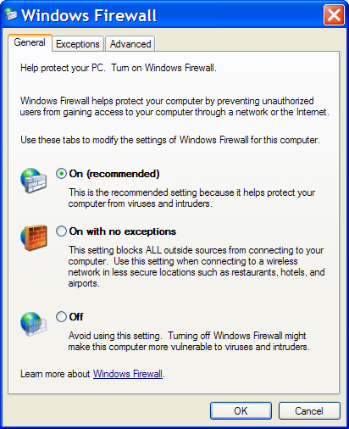
Network protection
The three major areas of improved network protection in Windows XP Service Pack 2 are the Windows Firewall, Distributed COM, and Remote Procedure Calls. In addition, some unnecessary services have been disabled by default.

Windows Firewall
Windows Firewall, a stateful filtering firewall previously known as Internet Connection Firewall (ICF), increases protection against probes that scan for information on open ports and active IP addresses, and denies all unsolicited inbound traffic. It allows outbound traffic to flow normally, and automatically accepts inbound responses to outbound requests.
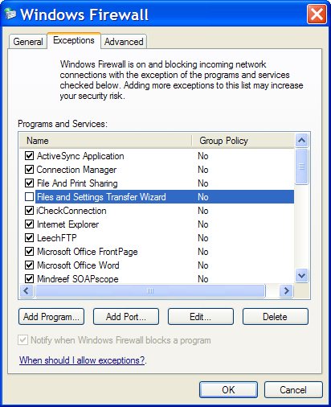
Stateful filtering works by examining a packet's state and the context information of a session. Windows Firewall uses a security policy with three primary rules:
- Any packet that matches an established connection flow is forwarded.
- A sent packet that does not match an established connection flow creates a new entry in the connection flow table and is forwarded.
- A received packet that does not match an established connection flow is dropped.
These three rules allow normal Internet access, such as browsing the Web and retrieving email, while preventing any unsolicited packet flow. The user or administrator can also declare exceptions to the security policy, to allow server applications to work.
Windows Firewall has three major states: On, On with no exceptions, and Off. The On state protects the computer but allows specific declared exceptions to the security policy. The "On with no exceptions" state can be used when a computer is used in an insecure environment, such as an unprotected public wireless network, or a local area network that has been infected with a virus. The Off state can be useful for brief periods, for diagnosing possible firewall-related problems, but shouldn't be used for extended periods.
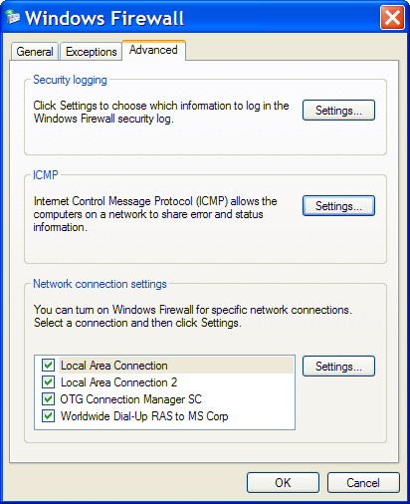
The firewall state can be set by the user, or by a domain administrator using a Group Policy. Similarly, firewall exceptions can be set by the user, or by a domain administrator using a Group Policy. The Group Policy always takes precedence if it exists; when a Group Policy is in place, the controls in the Windows Firewall control panel will be grayed out.
Windows Firewall can be enabled or disabled for specific network interfaces, although all are enabled by default. It can log dropped packets and/or successful connections. It has a number of options to control whether and how the computer responds to ICMP ("ping") requests; all of these are off by default, helping to make the computer invisible to probes.
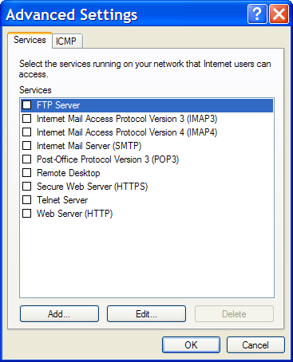
It is fairly simple to configure Windows Firewall to allow well-known services like Web and FTP servers to be accessed from the Internet using Windows Firewall's advanced settings. If the current computer is sharing the Internet connection for another computer that is actually hosting the service, that can be specified by editing the service description. The advanced settings also allow the specification of new services, and common services running on customized ports.
Whenever you enable an exception for Windows Firewall, you can make the exception either global or local. Global means that anyone can use the port, program or service from anywhere, even from the Internet. Local means that the port, program or service can only be used from the local subnet – the computer's own LAN.
In Windows XP Service Pack 2, the firewall driver has a static rule to perform stateful filtering, called a boot-time policy. This rule allows the computer to perform basic networking tasks such as DNS and DHCP and communicate with a domain controller to obtain policy. Once the firewall service is running, it loads and applies the run-time Windows Firewall policy and removes the boot-time filters. The boot-time policy cannot be configured.

Remote Procedure Call (RPC)
A Remote Procedure Call (RPC) is a message-passing facility that allows an application on one computer to call services that are available on various computers on a network. RPCs are commonly used to do remote administration of computers on a network, to share files and printers, and to build custom distributed applications.
Windows XP has a Remote Procedure Call subsystem (the rpcss network service) that provides the infrastructure for many other services and applications. The RPC subsystem takes care of mapping the endpoints of the available services and enables applications to use dynamic endpoints. The Remote Procedure Call Locator (rpclocator) service helps distributed application clients to find available compatible server applications.
Windows XP systems as normally installed have over 60 RPC-based services running that listen for client requests on the network, mostly in processes called Svchost.exe. If unprotected, these present a huge "attack surface" for intruders. In previous versions of Windows, ICF (the predecessor to Windows Firewall) blocked all RPC communications from outside the computer, which interfered with file and print sharing and remote administration as well as other useful services. This is one reason why many users did not run ICF.
Windows Firewall now takes a different, more compatible approach. When a process tries to open a port, claiming that it is an RPC service, Windows Firewall will accept this claim if and only if the caller is running in the Local System, Network Service, or Local Service security context – in other words, only if the process is actually a service. This reduces the chance that unprivileged Trojan horse programs will open a port for themselves by pretending to be RPC servers.
In addition, there is a new system policy for RPC servers that restricts their usage to local and/or authenticated clients. By default, the RPC runtime will reject all remote, anonymous calls. If a service registers a security callback that can authenticate remote, anonymous calls, then that service is granted an exemption. There is a new registry key, RestrictRemoteClients, that can modify this behavior to be more or less restrictive than the default, which administrators and developers can read about in http://msdn.microsoft.com/library/default.asp?url=/library/en-us/dnwxp/html/securityinxpsp2.asp and the online training at
http://msdn.microsoft.com/security.

Distributed Component Object Model (DCOM)
The Microsoft Component Object Model (COM) is a platform-independent, distributed, object-oriented system for creating binary software components that can interact. The Distributed Component Object Model (DCOM) allows applications to be distributed across locations on the network. The DCOM wire protocol transparently provides support for reliable and efficient communication between COM components.
Administrators typically configure COM servers to be available for remote use via DCOM. In previous versions of Windows, DCOM servers could sometimes present targets to remote attackers. In one scenario, an anonymous remote client would ask a DCOM server to perform a task that normally requires authentication. Since there are about 150 COM servers in a default installation of Windows XP, and no way to check their settings automatically, it would be difficult for an administrator to even determine the level of exposure on one computer, much less an entire network.
In Windows XP Service Pack 2, the security of DCOM has been enhanced. A system-wide setting restricts DCOM activation, launch, and call privileges, and differentiates between local and remote clients. By default, everyone is granted local launch, local activation, and local call permissions, which should enable all local scenarios to continue to work without change. By default, all authenticated users are granted remote call permissions, which enables most common server applications, as long as the client is not anonymous. By default, only administrators are granted remote activation and launch permissions.
In addition to the system-wide DCOM security settings, individual COM servers can be set to restrict the rights available to users. There are four new launch permission levels for COM servers: local launch, remote launch, local activate, and remote activate. There are two new access permission levels for COM servers: local calls and remote calls. The default permission levels will work properly for almost all cases.
Administrators and developers can read about the new DCOM security levels in http://msdn.microsoft.com/library/default.asp?url=/library/en-us/dnwxp/html/securityinxpsp2.asp and the online training at http://msdn.microsoft.com/security.

Alerter and Messenger services
The Alerter and Messenger services, which are sometimes used by administrators and developers to communicate over a network, have been disabled by default in Windows XP Service Pack 2. In previous versions of Windows, the Messenger service was started automatically, and could be abused by advertisers if no firewall was active. The Alerter service was available for manual start, but rarely used. Administrators and developers who use either of these services should read about the issues in http://msdn.microsoft.com/library/default.asp?url=/library/en-us/dnwxp/html/securityinxpsp2.asp. Most users will not see any effect from these services being disabled, other than noticing that some annoying popup messages from the Internet have stopped appearing.

Memory protection
Buffer overrun attacks are among the most common mechanisms, or vectors, for intrusion into computers. In this type of exploit, the attacker sends a long string to an input stream or control – longer than the memory buffer allocated to hold it. The long string injects code into the system, which is executed, launching a virus or worm.
Windows XP Service Pack 2 uses two general categories of protection measures to inhibit buffer-overrun attacks. On CPUs that support it, the operating system can turn on the execution protection bit for virtual memory pages that are supposed to hold only data. On all CPUs, the operating system is now more careful to reduce both stack and heap buffer overruns, using "sandboxing" techniques.

Execution Protection (NX)
On the 64-bit AMD K8 and Intel Itanium processor families, the CPU hardware can mark memory with an attribute that indicates that code should not be executed from that memory. This execution protection (NX) feature functions on a per-virtual memory page basis, most often changing a bit in the page table entry to mark the memory page.
On these processors, Windows XP Service Pack 2 uses the execution protection feature to prevent the execution of code from data pages. When an attempt is made to run code from a marked data page, the processor hardware raises an exception immediately and prevents the code from executing. This prevents attackers from overrunning a data buffer with code and then executing the code; it would have stopped the Blaster worm dead in its tracks.
Although the support for this feature is currently limited to 64-bit processors, Microsoft expects future 32-bit and 64-bit processors to provide execution protection.

Sandboxing
To help control this type of attack on existing 32-bit processors, Service Pack 2 adds software checks to the two types of memory storage used by native code: the stack, and the heap. The stack is used for temporary local variables with short lifetimes; stack space is automatically allocated when a function is called and released when the function exits. The heap is used by programs to dynamically allocate and free memory blocks that may have longer lifetimes.
The protection added to these two kinds of memory structures is called sandboxing. To protect the stack, all binaries in the system have been recompiled using an option that enables stack buffer security checks. A few instructions added to the calling and return sequences for functions allow the runtime libraries to catch most stack buffer overruns. This is a case where a little paranoia goes a long way.
In addition, "cookies" have been added to the heap. These are special markers at the beginning and ends of allocated buffers, which the runtime libraries check as memory blocks are allocated and freed. If the cookies are found to be missing or inconsistent, the runtime libraries know that a heap buffer overrun has occurred, and raise a software exception.

Safer message handling
Many viruses spread through file attachments to e-mail and instant messages. Virus writers capitalize on people's curiosity and willingness to accept files from people they know or work with, in order to transmit malicious files disguised as or attached to benign files.
Millions of people opened an email that said "I love you" even though it came from business associates that they barely knew. Millions of people opened what they thought was an image of tennis star Anna Kournikova. And, as we know, millions of people infected their computers, their networks, and their friends' computers with these viruses, which when activated mailed themselves to many of the contacts listed in the infected computers' address books.
Some attachment files, like plain text messages and simple images, are inherently safe. Other files, like binary executables, are inherently suspect. Still others might be safe, if certain easily detectable elements are absent, like an Excel spreadsheet without any macros. Zip files and other archives are themselves safe, but might contain other unsafe files.
Windows users and the operating system have traditionally distinguished file types by their extension: a file called ReadMe.txt is a plain text file that can be read in Notepad, while a file called ReadMe.doc is a Word document. Email and Web browsers also have the concept of a MIME type for files, and some applications and services "sniff" the content of files to determine the type of content they hold.
Microsoft Outlook increased its protection from email viruses once Outlook implemented attachment blocking as an internal function. Microsoft is now bringing this same kind of protection to Outlook Express, Windows Messenger, and other messaging applications, using a new system service for managing attachments. In the future, Outlook will use this system service rather than relying on its own internal methods for identifying safe and unsafe attachments.

Attachment Execution Service (AES)
Windows XP Service Pack 2 introduces the new Attachment Execution Service (AES) to control the viewing and execution of files attached to messages. AES has a COM interface that is in turn used by other programs, such as Outlook Express.
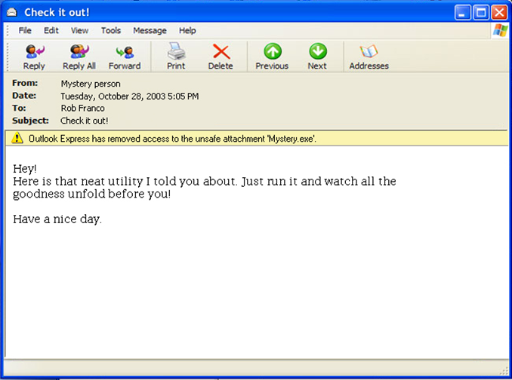
AES looks at a file and determines whether it is safe to view or execute based on several criteria. First, it looks at the file extension. It knows it can trust text files (.TXT), JPEG images (.JPG), and GIF images (.GIF). It can look up the associated application for a given MIME type and file extension, and make sure the two are consistent. It can decide whether a given association is safe or dangerous, based on a list. It can make sure that an antivirus is active and up-to-date before allowing the user to view or run unsafe files. It can also check the current security zone of the message source to control its policy.

AES in Outlook Express and Windows Messenger
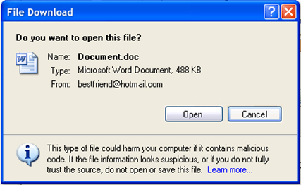
When Outlook Express opens an email that has an attachment, it now calls AES to determine if the attachment is safe. If the attachment is clearly safe, it will be completely available to the user. Safe images will be displayed, and safe attached plain text files will show as available attachments.
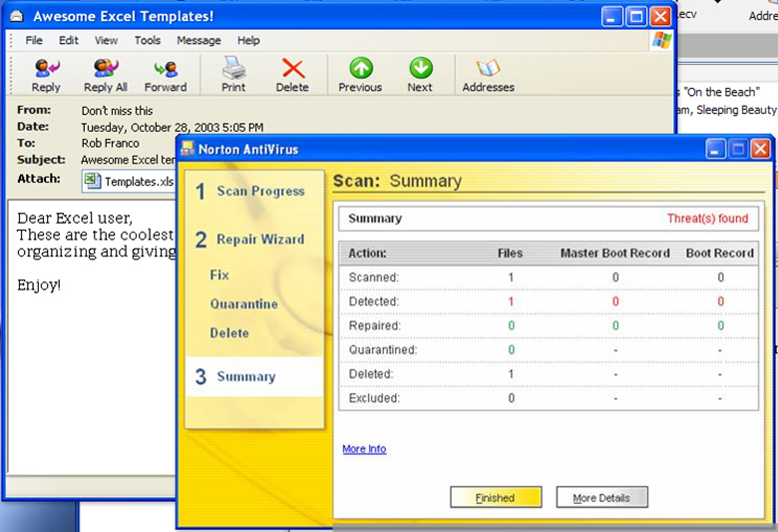
If the attachment is clearly unsafe, like a binary executable, it will be blocked: the user will not be able to open it at all, but will see a notice of the blockage. If the attachment might be safe and might be dangerous, the user will see a warning prompt when attempting to drag, save, open, or print the file. If the user accepts the option, the file will be handled in a way that is guaranteed to trigger any active antivirus program.
Windows Messenger uses similar logic and identical dialogs for handling file attachments. The one major difference is that email attachments are normally downloaded without any intervention by the user, while instant messaging attachments normally require the recipient's permission before they can be sent.

HTML content blocking in Outlook Express
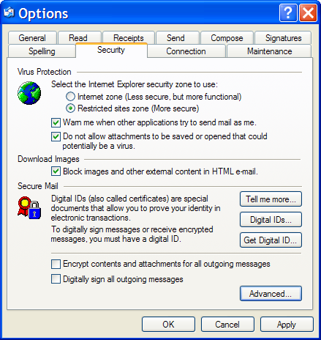
One technique that spammers and viruses use to target active email users is to include external content, such as images, in HTML email. When the email calls out to the Web site that hosts the image, the "hit" can be recorded by the Web server and used to identify the recipient.
To preserve the user's privacy and prevent future attacks, Outlook Express now blocks external images and other external content in HTML mode. This option can be globally disabled by the user, and when the option is active the user can load the blocked external content for an email message with one mouse click.
As we will see, running binary behaviors, which use a specialized kind of COM interface that is a feature of Internet Explorer, has been disabled in the Restricted Sites zone by default. Outlook Express runs its HTML email using the rules of the Restricted Sites zone by default, although that can be configured by the user.
However, Outlook Express has now restricted binary behaviors. There is no legitimate reason for an email to use binary behaviors, so from Service Pack 2 onwards Outlook Express will never allow them.
As an additional safety measure, when the user sets Outlook Express to read all messages in plain text, Outlook Express uses the less complicated rich edit control instead of the more complicated HTML browser control (mshtml) from Internet Explorer. This choice presents no disadvantages to the end user, while offering a reduced surface to attackers. There are also another dozen areas in Outlook Express where tightened security has been obtained without affecting users.

More secure browsing
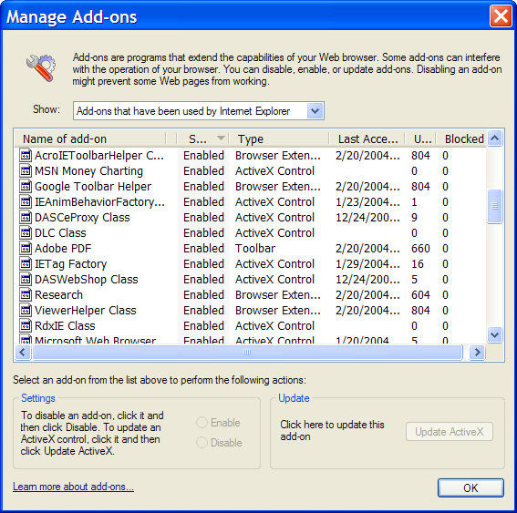
In the past, add-ons to Internet Explorer – ActiveX controls, browser extensions, and toolbars – could sometimes become a problem. While many add-ons are useful, some can be unwanted or cause crashes. For example, several advertising companies use add-ons to cause their own pop-up advertisements to display when the user views a Web page with related content.
The new version of Internet Explorer in Windows XP SP 2 includes add-on management and crash detection. Add-on Management allows users to view and control the list of add-ons that can be loaded by Internet Explorer. It also shows the presence of some add-ons that were previously not shown and could be very difficult to detect.
Add-on Crash Detection attempts to detect crashes in Internet Explorer that are related to an add-on, and gives the user the option to disable add-ons. In addition, administrators can now apply policies about allowed add-ons across an enterprise.
Internet Explorer has supported binary behaviors since version 5. A binary behavior is a component that supports two special COM interfaces that Internet Explorer will recognize and use. A binary behavior can add even more functionality to Internet Explorer than can be accomplished with scripts. In the version of Internet Explorer shipped with Windows XP SP2, there is a way to better control binary behavior security.
Binary behaviors are now disabled in the Restricted Sites zone by default. Since HTML-formatted e-mail is rendered in the Restricted Sites zone by default in most e-mail readers, e-mail is now less vulnerable to viruses and worms based on binary behaviors.
When Internet Explorer opens a Web page, it places restrictions on what the page can do, based on the location of the Web page. For example, Web pages that are located on the Internet might not be able to perform some operations, such as accessing information from the local hard drive.
On the other hand, Web pages on the local computer are in the Local Machine zone, where they have the fewest security restrictions. The Local Machine zone is an Internet Explorer security zone, but is not displayed in the settings for Internet Explorer. The Local Machine zone allows Web content to run with fewer restrictions. Unfortunately, attackers also try to take advantage of the Local Machine zone to elevate their privileges and compromise a computer.
In Windows XP Service Pack 2, all local files and content that is processed by Internet Explorer has the security of the Local Machine zone applied to it. This differs from previous versions, where local content was considered to be secure and had no zone-based security was placed on it.
This feature dramatically restricts HTML in the Local Machine zone and HTML that is hosted in Internet Explorer. This helps to mitigate attacks where the Local Machine zone is used as an attack vector to load malicious HTML code.
ActiveX script in local HTML pages that are viewed inside of Internet Explorer no longer runs. Script in local HTML pages viewed inside of Internet Explorer now prompts the user for permission to run. Administrators and developers who have scripts that need to run in local HTML pages should read about this issue in http://msdn.microsoft.com/library/default.asp?url=/library/en-us/dnwxp/html/securityinxpsp2.asp.
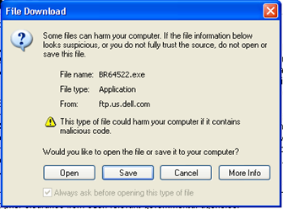
As we discussed in the context of attachments to messages, files types can be identified in many ways, including "sniffing" the contents for recognizable internal bit signatures. When files are served to the client, Internet Explorer uses the following pieces of information to decide how to handle the file:
- File name extension
- Content-Type from the HTTP header (MIME type)
- Content-Disposition from the HTTP header
- Results of the MIME sniff
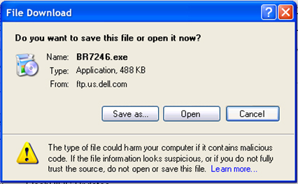
In Windows XP Service Pack 2, Internet Explorer requires that all file-type information that is provided by Web servers is consistent. For example, if the MIME type of a file is “text/plain” but the MIME sniff indicates that the file is really an executable file, Internet Explorer renames the file by saving the file in the Internet Explorer cache and changes its extension. (In a MIME sniff, Internet Explorer examines, or sniffs, a file to recognize the bit signatures of certain types of files.)
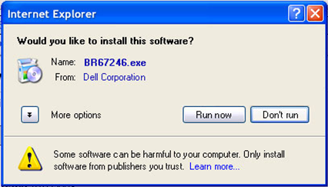
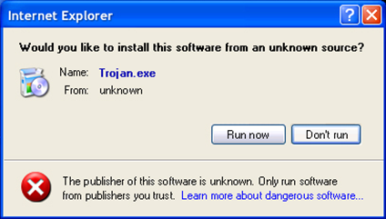
We also discussed the Attachment Execution Service (AES) in the context of email attachments and files transferred via instant messaging applications. Internet Explorer uses AES to check downloaded files for safety, and to display dialogs to the user when permission is needed. The AES dialogs give the user more information and guidance than were available in previous versions of Windows and Internet Explorer. In addition to showing the source, type and size of a downloaded file, AES shows the user the publisher of executable software being installed, and issues a strong warning about software from an unknown source.
In an attempt to grab the user's attention for advertising, many Web sites display ads in pop-up or pop-under browser Windows. Several third-party pop-up blockers have been offered to help lessen this annoyance for users, but some of these pop-up blockers have caused problems of their own. The new Pop-up Manager in Internet Explorer blocks most unwanted pop-up windows from appearing. Pop-up windows that are launched when the end user clicks a link will not be blocked. End users and IT administrators can let specific domains launch programmatic pop-up windows.
The new version of Internet Explorer has another dozen security improvements, most of which do not affect users in normal circumstances. A few of these are better security for ActiveX controls and other scriptable objects, fewer possibilities for buffer overruns, better protection against windows placed on top of other windows, and better protection against windows placed off-screen.

Improved computer maintenance
A number of new features in Windows XP Service Pack 2 make it easier for users to maintain their computers. Updates are automatic, patches are smaller and can be removed, and there is a centralized user interface for all security-related maintenance.

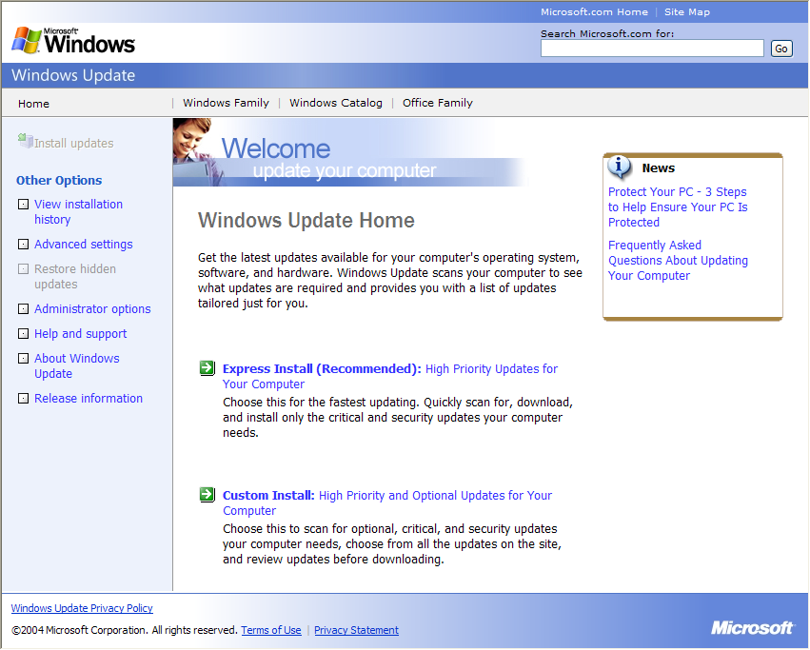
Windows Update 5
Windows XP Service Pack 2 uses a new version of the Windows Update Web site, and simplified options for automatic updating. The Express Install option on the Windows Update 5 site lets the user quickly scan for, download, and install only the critical and security updates his computer needs.
The Automatic Updates control panel allows the user to update the computer automatically at scheduled times, which makes maintenance a set-and-forget activity. Users can also choose to download updates automatically but not install them, just get notification of update availability, or handle updates manually.

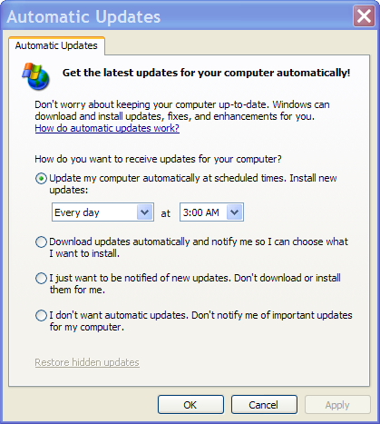
Windows Installer 3
The Windows Installer service defines and manages a standard format for application setup, installation, and upgrades. It tracks components such as groups of files, registry entries, and shortcuts. Windows Installer is a system-resident installation service that provides consistent deployment, enabling administrators and users to manage shared resources, customize installation processes, make decisions on application usage, and resolve configuration problems. Windows Installer 3.0 is a new version of the service that is included in Windows XP Service Pack 2.
Windows Installer 3.0 has enhanced inventory functions that identify what patch components do and don't need to be downloaded, and supports Microsoft's delta compression technology, which makes patches smaller. Windows Installer 3.0 also supports more reliable patch removal.

Security Center
Windows Security Center is the centralized place in Windows XP Service Pack 2 for users to learn anything about security and perform any security-related tasks. Security Center monitors the status of three major security functions: the firewall, automatic updates, and virus protection. If Security Center detects a problem with any of these, typically at boot time, it will display an icon and balloon message in the Windows taskbar notification area.
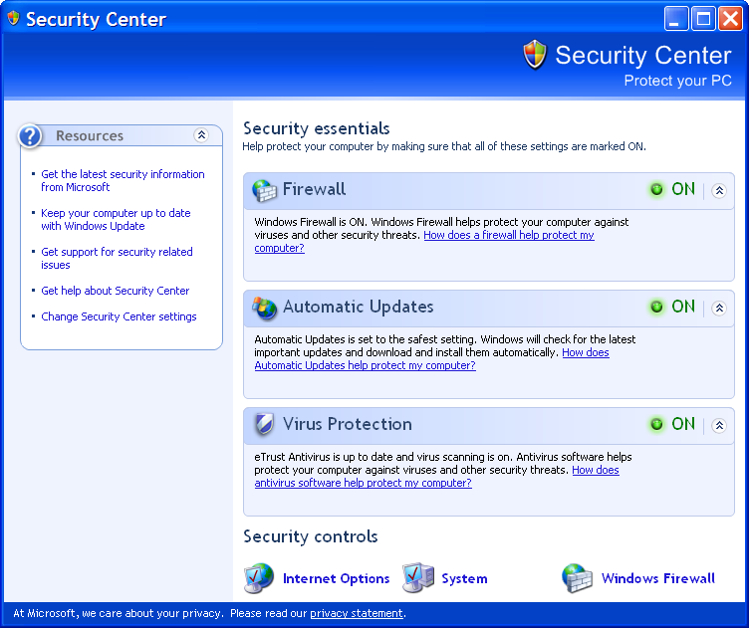
The prescription offered by Windows Security Center is to have an active firewall; to allow for daily, automatic updates of the Windows system; and to have an active antivirus with up-to-date signatures. The status of each of these prescription elements is displayed in Security Center as a stop light.
Security Center knows about Windows Firewall, and about several third-party firewalls. It knows about the most common antivirus solutions. It has an open interface that third-party antivirus and firewall vendors can use to allow Security Center to detect the presence of their software and report its status. Users can tell Security Center that they have an undetected third-party solution, or turn off notifications about specific security vulnerabilities that don't apply in their environment.

Summary
As we've seen, Windows XP Service Pack 2 addresses new challenges to the security of personal computers by making a number of basic improvements to the operating system. It reduces common attack vectors four ways: it protects the network, protects memory, handles e-mail more safely, and browses the Internet more securely. Service Pack 2 also makes it easier to keep the system up-to-date.
Network protection is provided by the Windows Firewall, improvements to the Distributed COM security infrastructure, and improvements to the Remote Procedure Call security infrastructure. Enhanced memory protection comes from support of execution protection on compatible CPUs, and "sandboxing" of the stack and heap on all CPUs.
Message handling is safer thanks to a new Attachment Execution Service, which is used by Outlook Express, Windows Messenger, and other email and instant messaging applications. Numerous improvements to Internet Explorer make browsing more secure and more stable.
In Windows XP Service Pack 2, updates can be fully automatic. Patches are smaller and can always be removed. And, finally, Windows Security Center provides a centralized user interface for all security-related maintenance.

Glossary
Antivirus: software intended to protect a computer against harmful virus, worm, and Trojan horse programs.
Bluetooth: a low cost short-range wireless specification for connecting mobile devices and bringing them to market.
Cable modem: a device that enables a computer or router to send and receive data over cable TV lines at high speeds.
DCOM (Distributed Component Object Model): a set of concepts and program interfaces in which client program objects can request services from server program objects residing on other computers in a network. DCOM is based on the Component Object Model (COM).
DSL (Digital Subscriber Line): a technology for bringing high-bandwidth information to homes and small businesses over ordinary copper telephone lines.
Firewall: a set of programs, which may run on a computer, a router, or a dedicated device, to protect the resources of a computer or network from other computers or networks, typically by filtering network packets.
Internet: a worldwide system of computer networks using the TCP/IP protocols.
Network: a series of points or nodes (computers, routers, and other devices) interconnected by communication paths (optical fiber, coaxial cable, twisted pair, or other physical links). Networks can interconnect with other networks and contain subnetworks.
Patch: a quick repair or fix for a program, generally provided by the software maker to be applied in the field. Multiple patches may be combined into service packs after more extensive testing.
Port: a physical or logical connection to a computer. TCP/IP ports are numbered and assigned to specific services. For example, port 80 is the default port for HTTP, used by most Web servers.
Remote procedure call (RPC): a protocol that one program can use to request a service from a program located in another computer in a network without having to understand network details.
Service Pack: an update to a customer's software that fixes existing problems and, in some cases, delivers product enhancements. Service packs may include multiple patches that have been tested together.
Trojan horse: a program in which malicious or harmful code is contained inside apparently harmless programming or data in such a way that it can get control and do its chosen form of damage. The term comes from an episode in Homer's Iliad.
Virus: a piece of programming code usually disguised as something else that causes some unexpected and usually undesirable event. A virus is often designed so that it is automatically spread to other computer users. Viruses can be transmitted as attachments to an e-mail note, as downloads, or be present on a diskette or CD.
Worm: self-replicating virus that does not alter files, but resides in active memory and duplicates itself.

This is a preliminary document and may be changed substantially prior to final commercial release of the software described herein.
The information contained in this document represents the current view of Microsoft Corporation on the issues discussed as of the date of publication. Because Microsoft must respond to changing market conditions, it should not be interpreted to be a commitment on the part of Microsoft, and Microsoft cannot guarantee the accuracy of any information presented after the date of publication.
This white paper is for informational purposes only. MICROSOFT MAKES NO WARRANTIES, EXPRESS OR IMPLIED, IN THIS
DOCUMENT.
Complying with all applicable copyright laws is the responsibility of the user. Without limiting the rights under copyright, no part of this document may be reproduced, stored in, or introduced into a retrieval system, or transmitted in any form or by any means (electronic, mechanical, photocopying, recording, or otherwise), or for any purpose, without the express written permission of Microsoft Corporation.
Microsoft may have patents, patent applications, trademarks, copyrights, or other intellectual property rights covering subject matter in this document. Except as expressly provided in any written license agreement from Microsoft, the furnishing of this document does not give you any license to these patents, trademarks, copyrights, or other intellectual property.
© 2004 Microsoft Corporation. All rights reserved.
Microsoft, Windows, and the Windows logo are either registered trademarks or trademarks of Microsoft Corporation in the United States and/or other countries.

Haverford College was one that took the restrictive approach, successfully.
Brown University was one that had to shut down its network after its permissive policy failed.
http://www.treas.gov/offices/inspector-general/evaluation-reports/ca04001.pdf

